JANUARY 2025 CHURCH SERVICES Lark Valley & North Bury Team
▪ St Mary, Culford IP28 6TU  St Catherine of Alexandria, Flempton cum Hengrave IP28 6EL  Fornham All Saints IP28 6JW   Fornham St Martin cum St Geneviève IP31 1SW  St Lawrence, Lackford IP28 6HZ  St Andrew, Timworth IP31 1HY   St Mary, West Stow & Wordwell IP28 6ET  All Saints IP33 3QW  St George IP32 6JZ  St John the Evangelist IP33 1SP  www.northburychurches.org.uk
 |  |  |  |  |  |  |  |  |  |  | 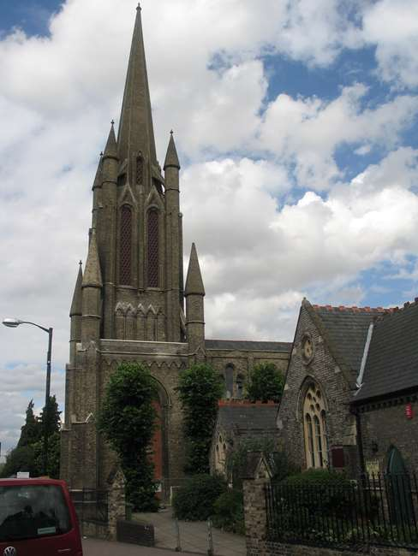
 | 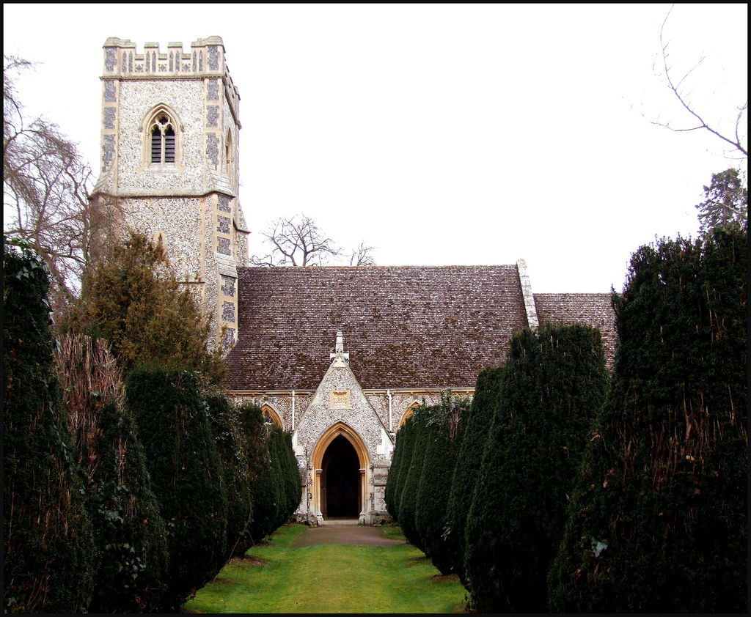 | 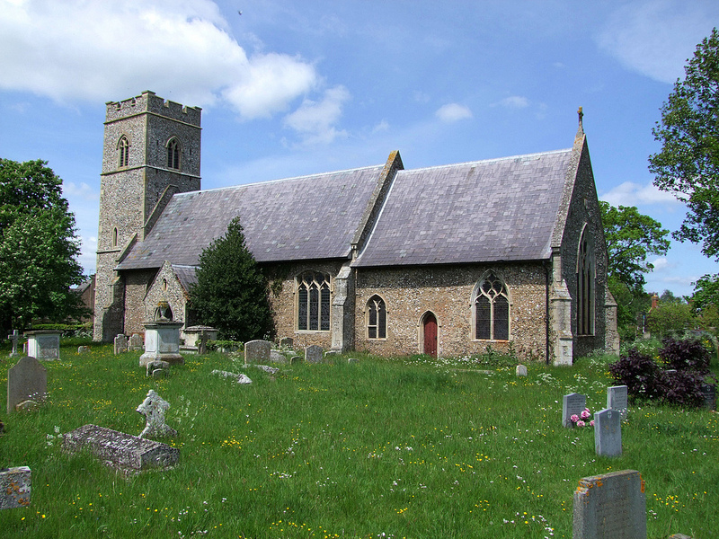 | 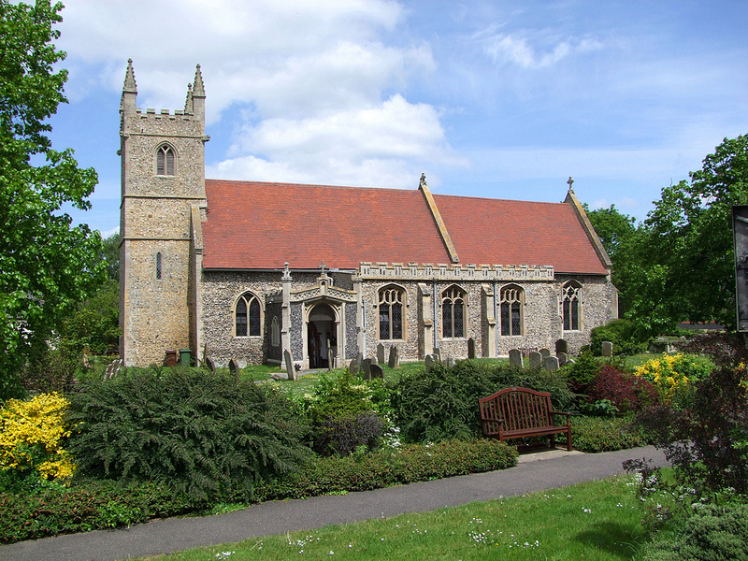 | 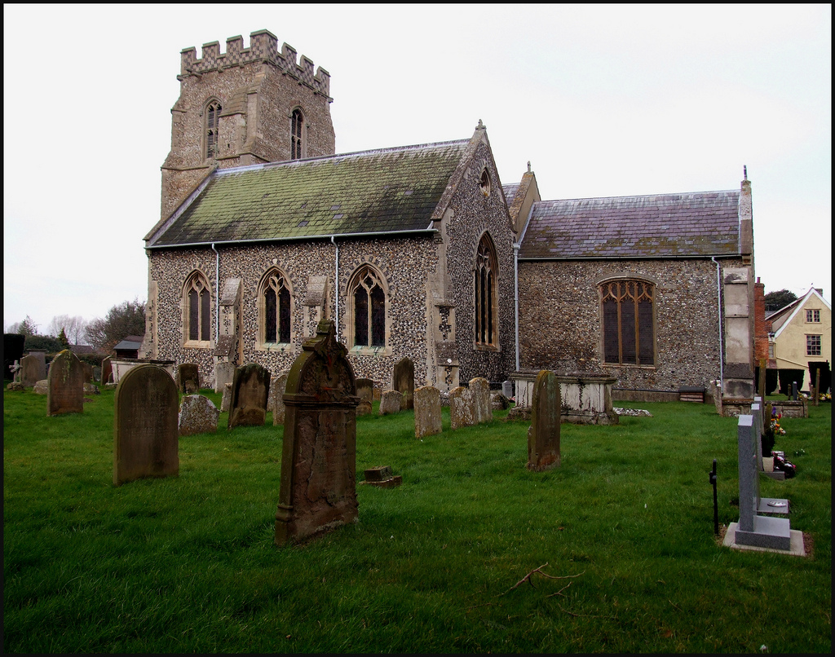 | 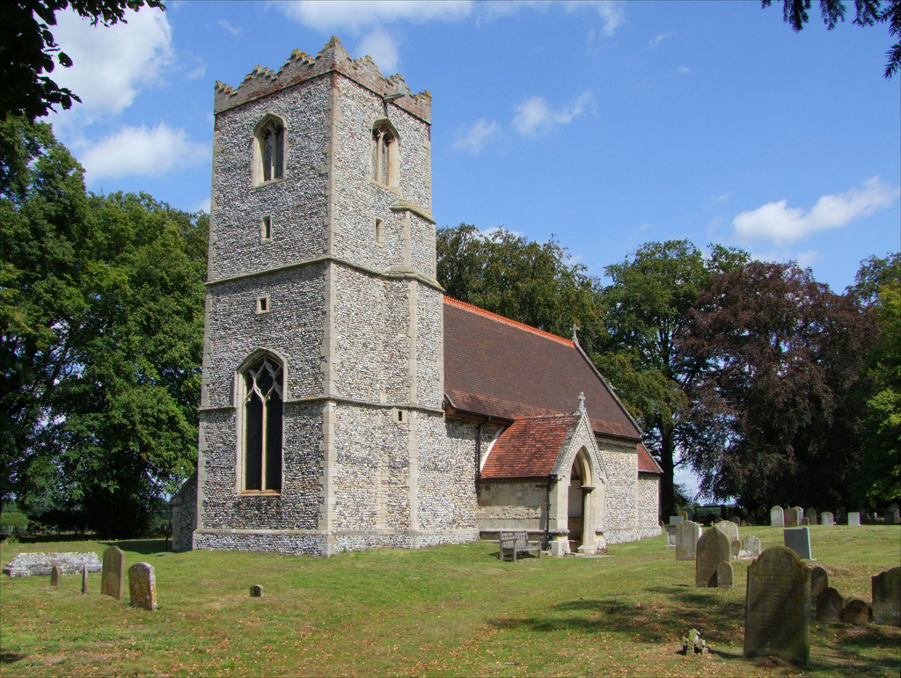 | 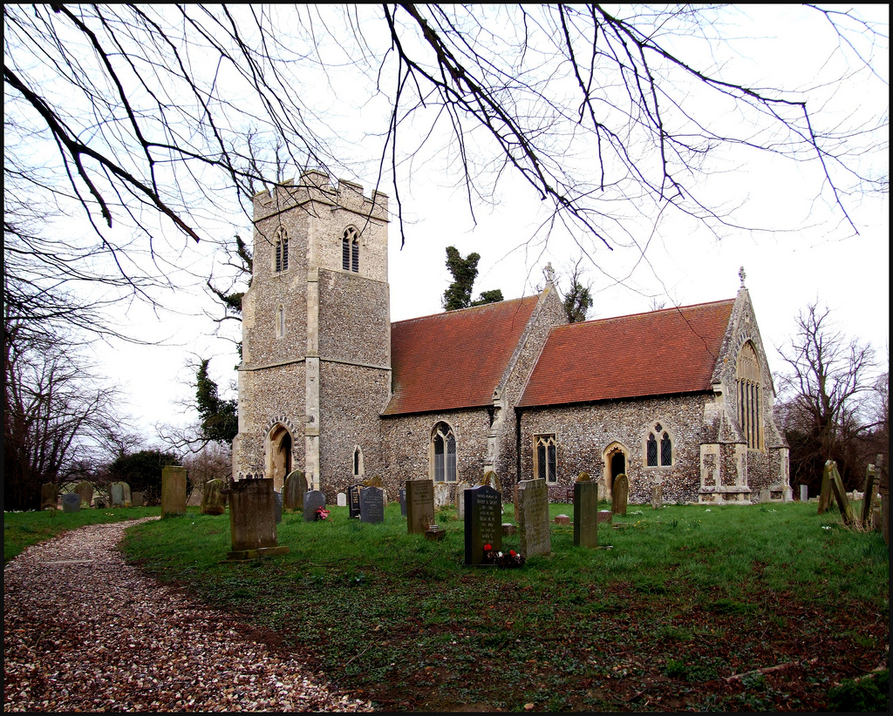 | 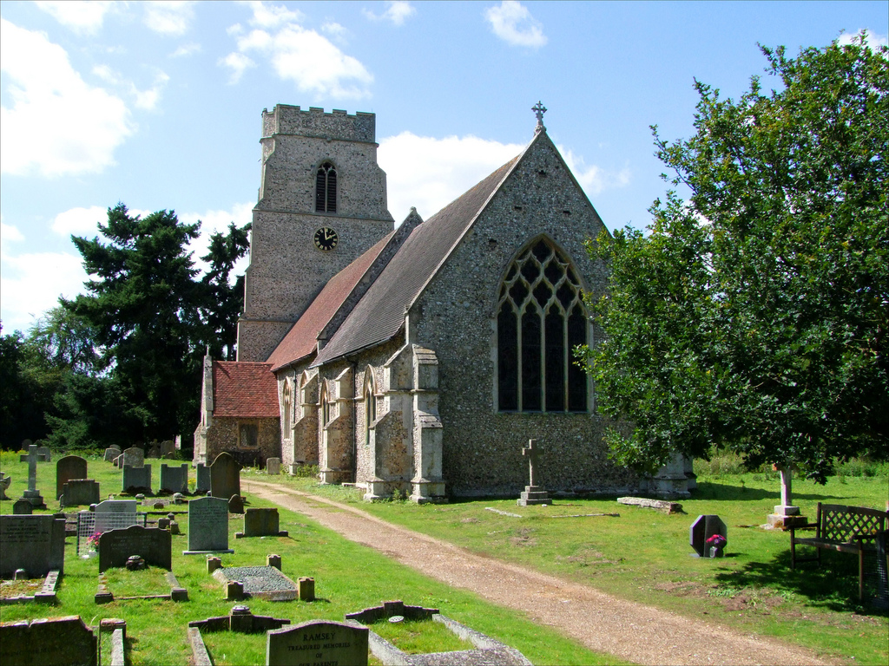 | 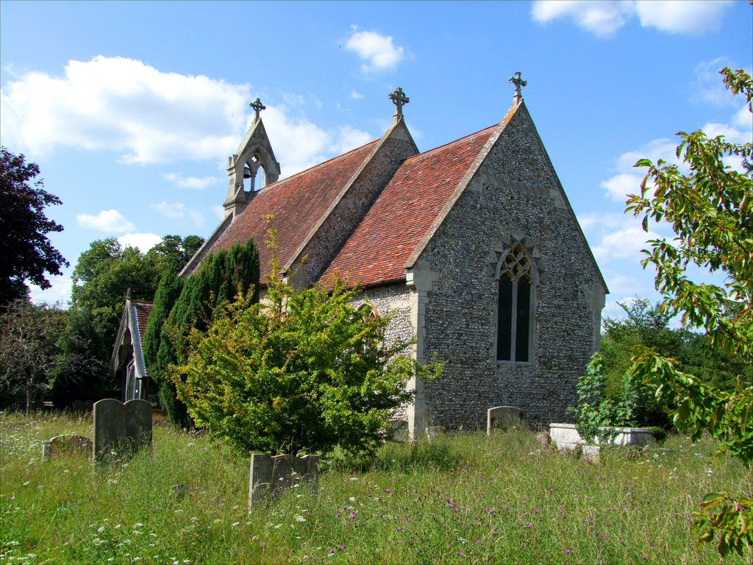 | 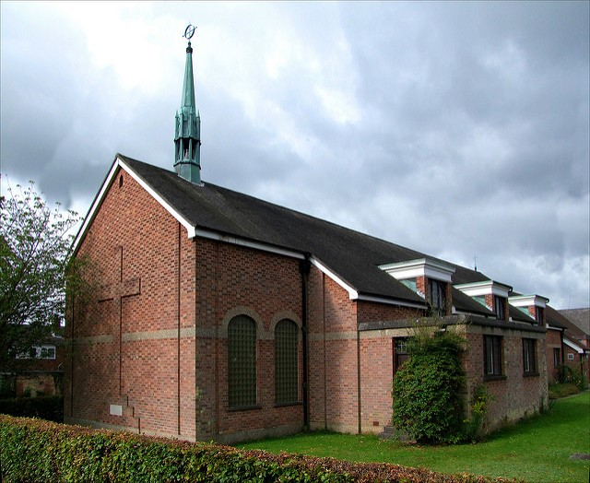 | 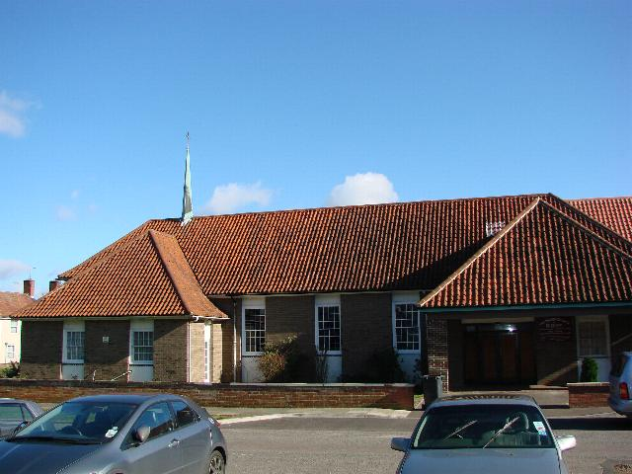

5th January 2025, Epiphany
08.00 Holy Communion (BCP) All Saints Bury  09.30 Parish Communion (CW) All Saints Bury  09.30 Parish Communion (CW) St George’s  09.30 Holy Communion (BCP) Timworth | 10.00 Parish Eucharist (CW) West Stow  10.00 All Age Service Fornham All Saints  11.00 Parish Eucharist (CW) St John’s  15.00 Wonder Club Lackford
12th January, Baptism of Christ
08.00 Holy Communion (BCP) Culford  08.00 Holy Communion (BCP) All Saints Bury  09.30 Parish Communion (CW) All Saints Bury  09.30 Parish Communion (CW) St George’s | 10.00 Parish Eucharist (CW) Lackford  10.00 Parish Eucharist (CW) Fornham St Martin  11.00 Parish Eucharist (CW) St John’s  17.00 Team Epiphany Carols St John’s
19th January, Second Sunday of Epiphany
08.00 Holy Communion (BCP) All Saints Bury  09.30 Matins (BCP) Timworth  09.30 Parish Communion (CW) St George’s  09.15 Parish Breakfast followed by  10.00 Said Communion Service (CW) West Stow | 10.00 Parish Eucharist (CW) Fornham All Saints  10.30 All Age Service All Saints Bury  11.00 Parish Eucharist (CW) St John’s  14.00 .Baptism St John’s
26th January, Third Sunday of Epiphany
08.00 Holy Communion (BCP) All Saints Bury  09.30 Parish Communion (CW) All Saints Bury  09.30 Parish Communion (CW) St George’s  10.00 Parish Eucharist (CW) Fornham St Martin |  | 10.00 Parish Eucharist (CW) Culford  11.00 Parish Eucharist (CW) St John’s  12 noon Holy Communion (BCP) Flempton

WEEKDAY SERVICES IN JANUARY 2025

Tuesdays 7th, 21st 10.00 Eucharist (CW) Fornham St Martin

18.00 Meditation [half an hour] St John’s

Wednesdays 08.30 Morning Prayer St John’s

09.30 Eucharist (CW) St John’s

Except 1st 17.00 Evening Prayer St George’s

Thursdays 2nd, 16th 09.30 Holy Communion (BCP) All Saints Bury

2nd 14.00 Wedding Blessing Culford

9th, 23rd, 30th 09.30 Eucharist (CW) All Saints Bury

9th 18.00 Adoration and Benediction St John’s

Fridays 17.15 Evening Prayer St John’s

18.00 Eucharist (CW) St John’s

Saturdays 25th 09.30 Eucharist (CW) St John’s

25th 12.30 WPCU Lunch prayers St John’s

